If you close the door - The Velvet Underground 1969 4/4 bpm 120

One, two, three
C A7
If you close the door
Dm G
The night could last forever
C A7
Leave the sunshine out
Dm G
And say hello to never

C C7
All the people are dancing and they're having such fun
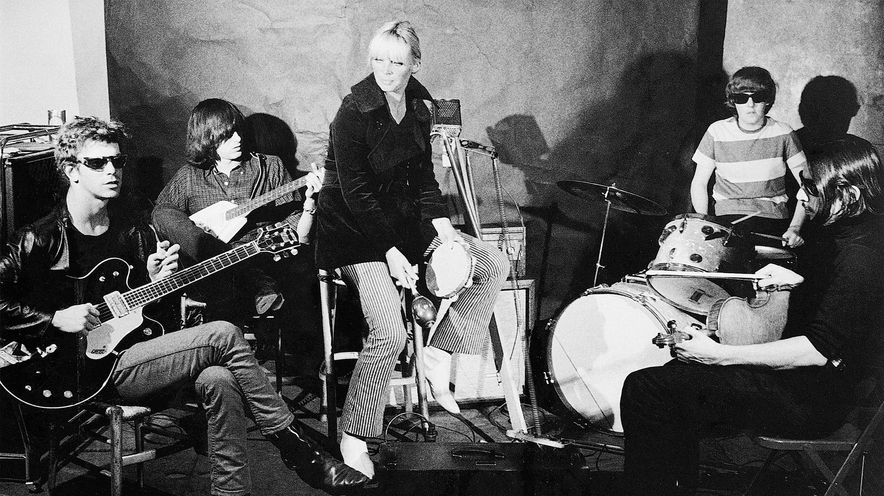
F Fm
I wish it could happen to me
C A7
But if you close the door
Dm G C
I'd never have to see the day again

C A7
If you close the door
Dm G
The night could last forever
C A7
Leave the wine glass out
Dm G
And drink a toast to never

C C7

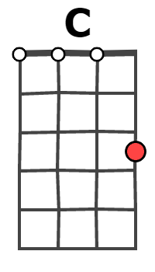 | 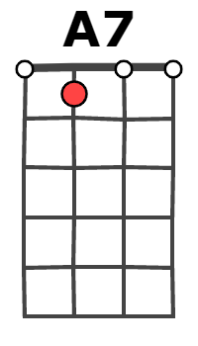
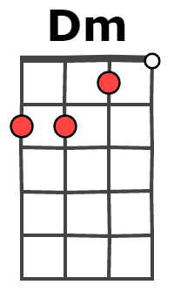 | 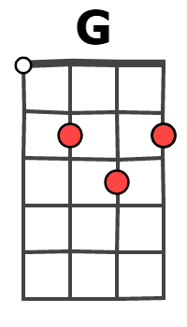
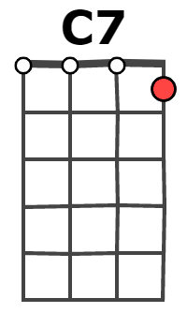 | 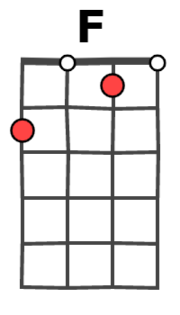
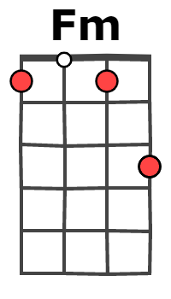 | 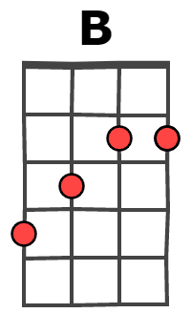
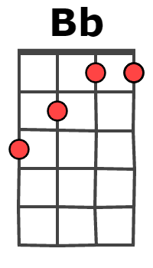 | 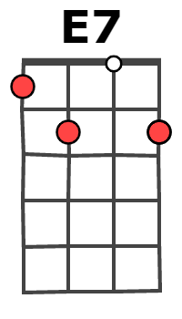
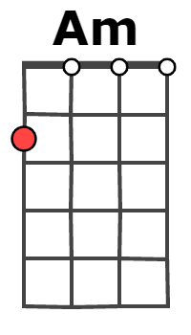 | 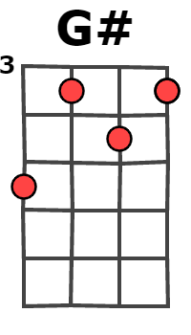

Oh, someday I know someone will look into my eyes
F
And say hello
Fm
You're my very special one ...
C A7
But if you close the door
Dm G C
I'd never have to see the day again
Bass line to bridge: C - B - Bb

Am E7
Dark party bars, shiny Cadillac cars
Am E7 Am Am G# G
And the people on subways and trains
Dm A7
Looking gray in the rain as they stand disarrayed
F G
Oh but people look well in the dark

C C7
All the people are dancing and they're having such fun
F Fm
I wish it could happen to me ...
C A7
Cause if you close the door
Dm G C
I'd never have to see the day again

Dm G C A7
I'd never have to see the day again, ... once more
Dm G C
I'd never have to see the day again

